**4. Docker Basics**

1. List few benefits of docker
2. Portability
3. Isolation
4. Efficiency
5. Rapid Deployment
6. Version Control
7. Ecosystem and Collaboration
8. DevOps Support
9. Continuous Integration and Testing
10. Scalability
11. Micro services Architecture
12. Install docker
13. Check docker version and copy the output

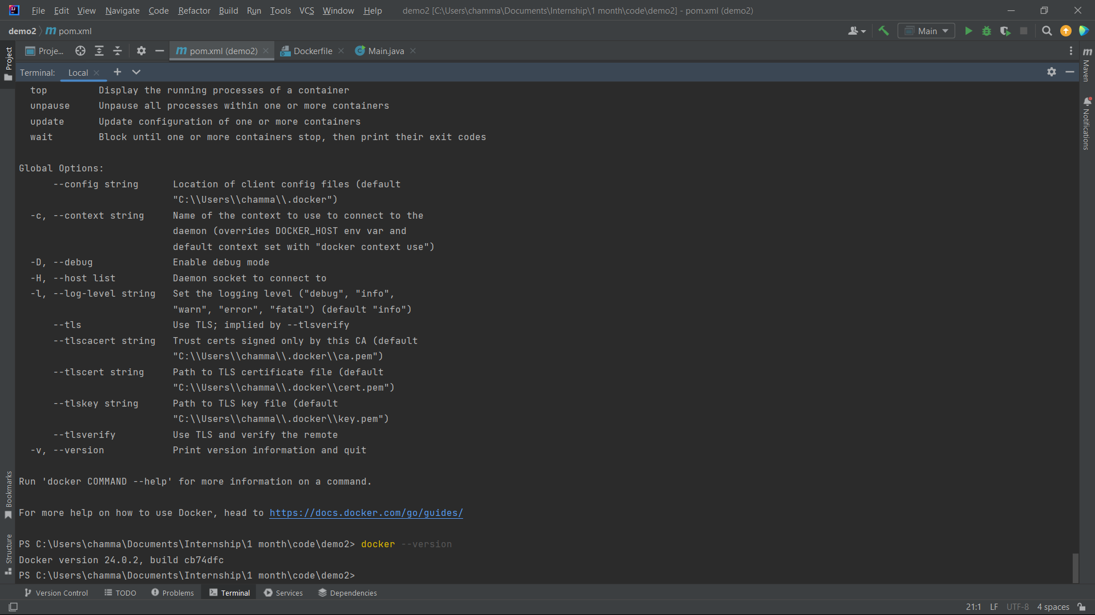

1. Create a new java project with maven
2. Create a main class and print “Hello docker example”
3. Create a jar file for the project (inside target directory)
4. Run the generated jar file inside target directory with command line
5. Display the output

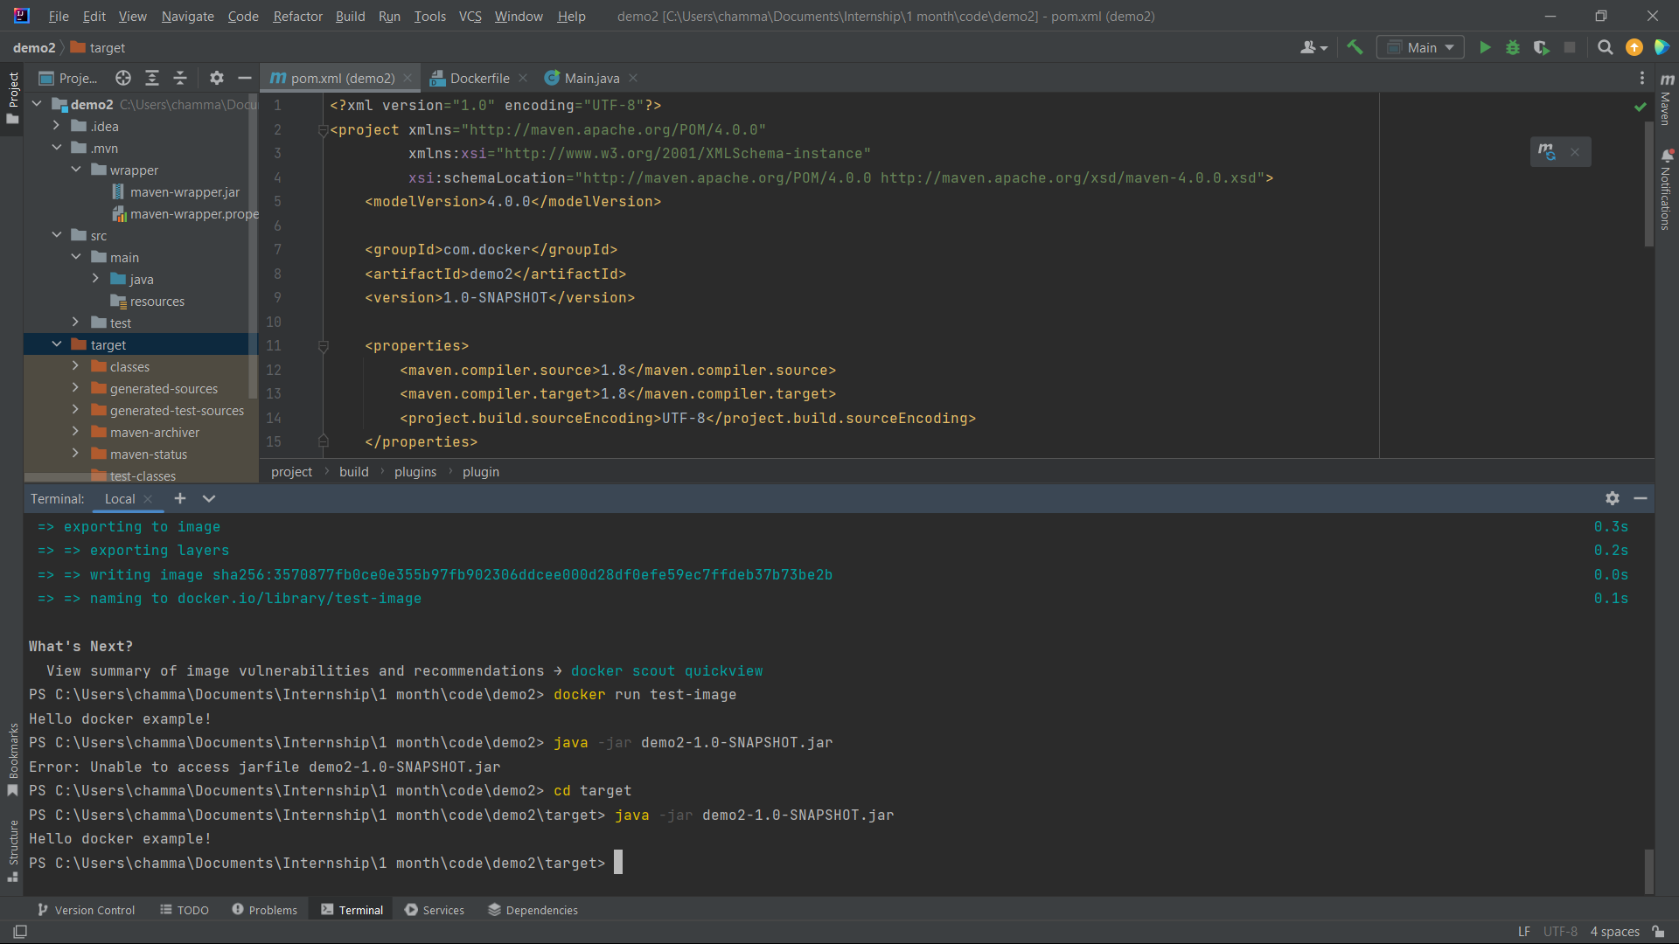

1. Create a docker image for the java project. What is the command you used?

docker build -t my-image .

1. List all the docker images and show output

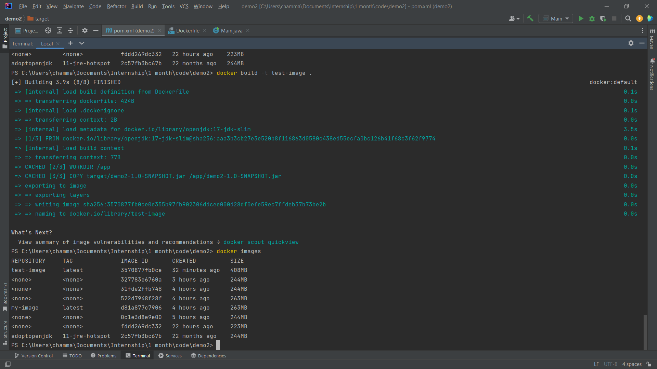

1. Run the created docker image. What is the command you used?

docker run test-image

1. List all the docker images and show output



1. Stop the docker container?
2. List all the docker containers and show output

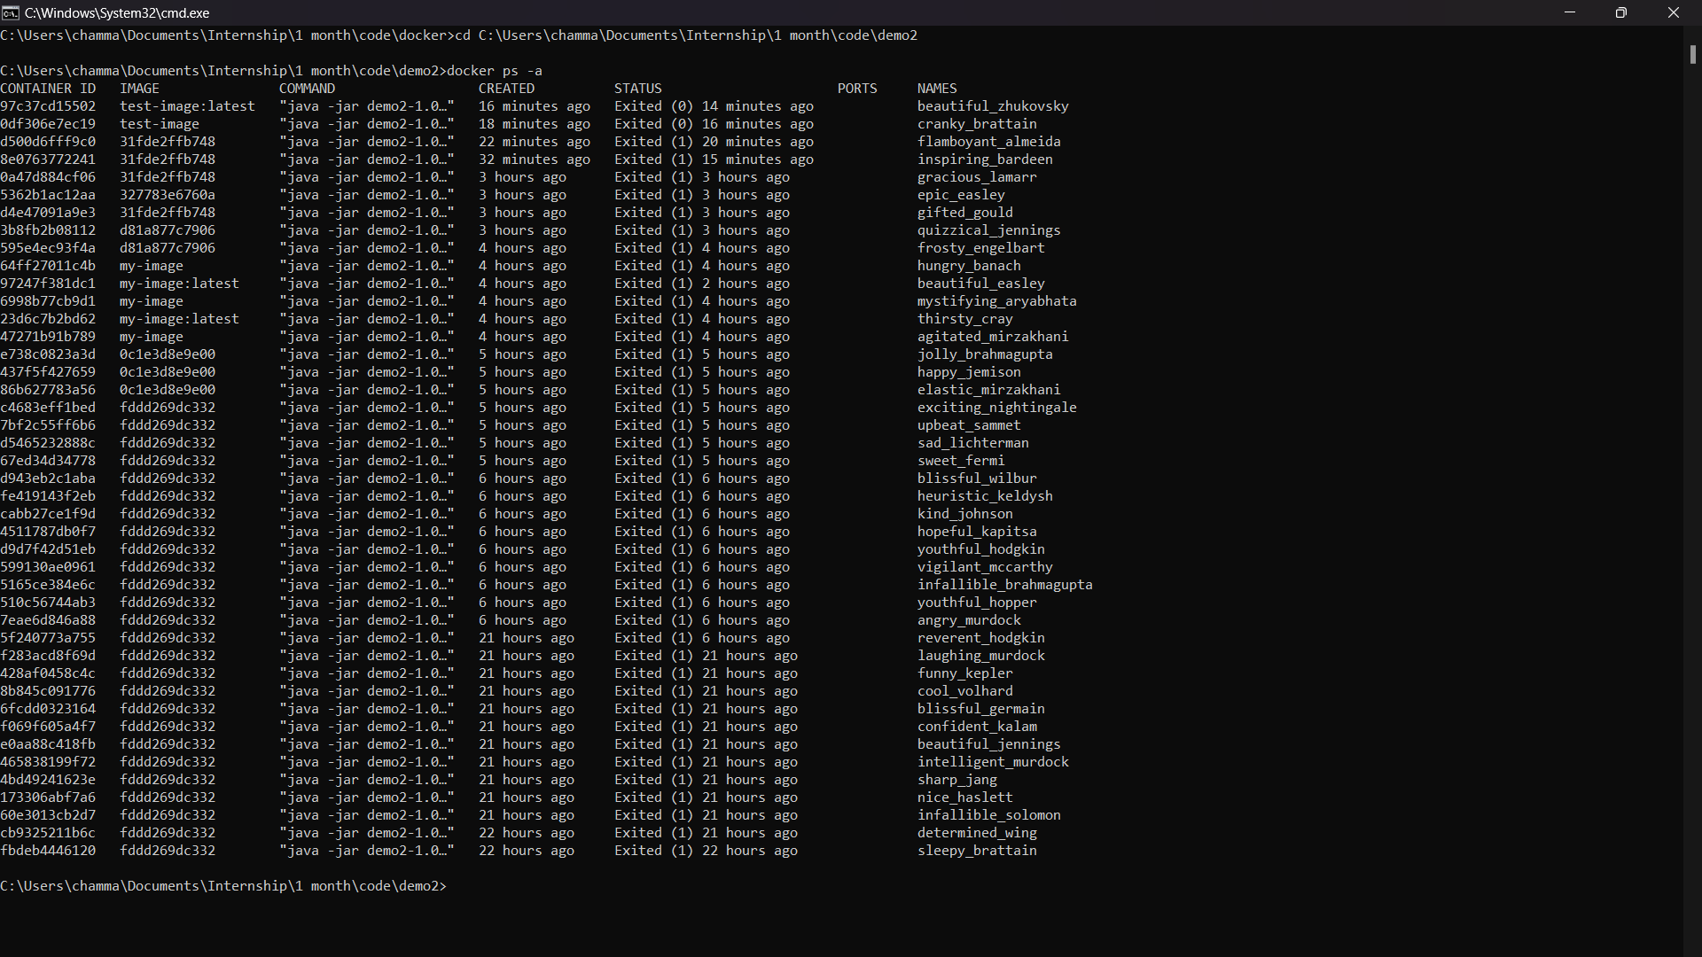

1. Remove the docker image. What is the command you used?

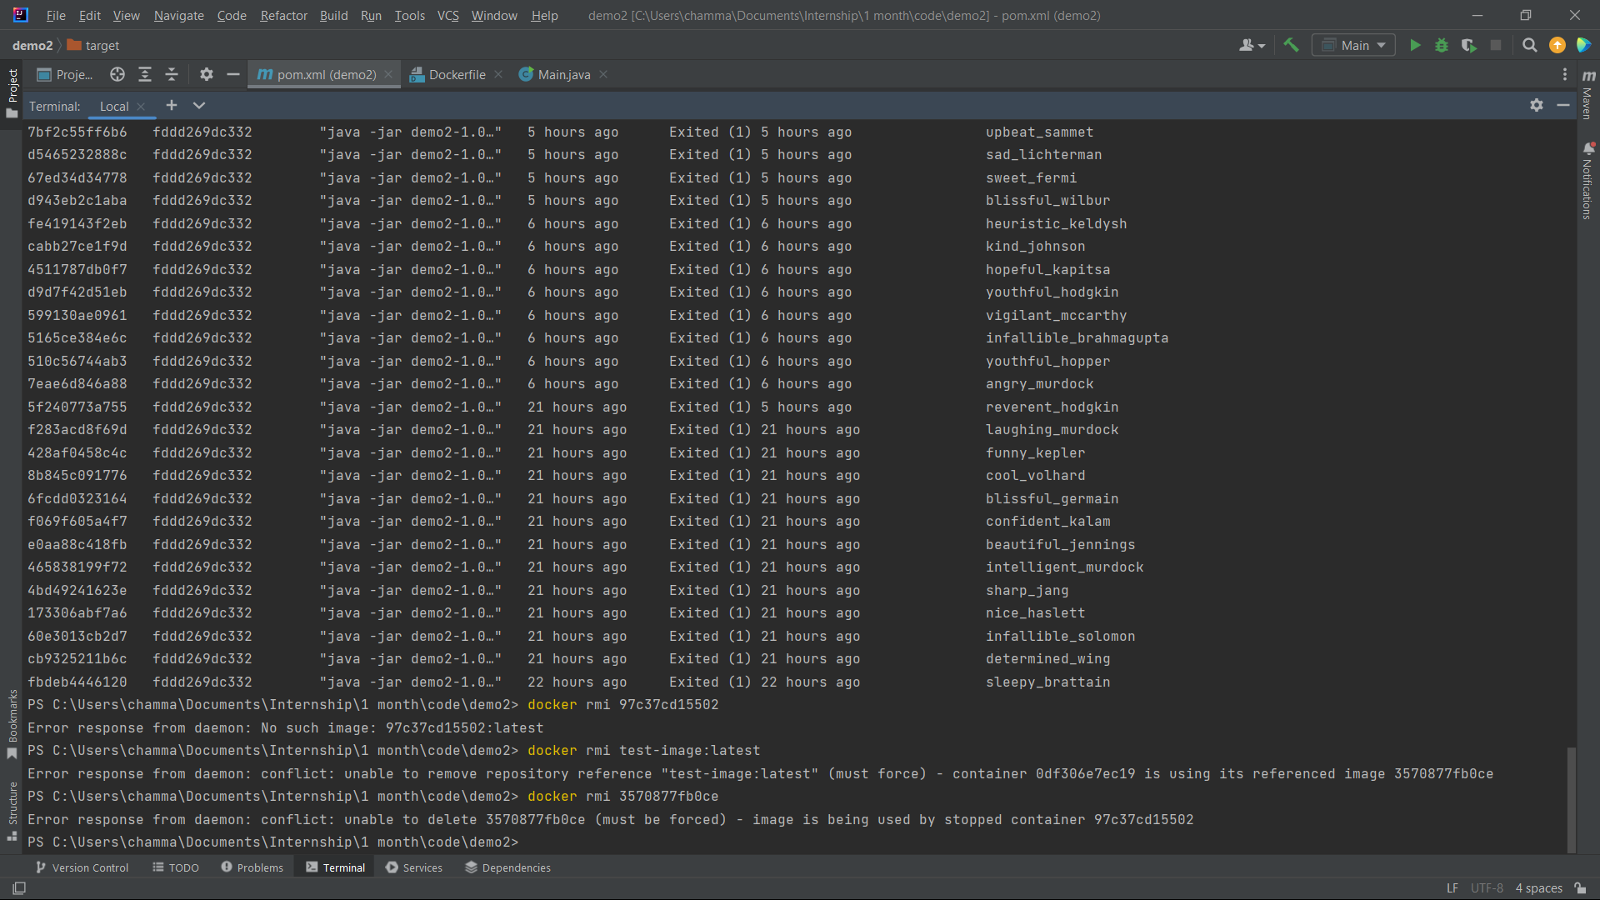

docker rmi -f 3570877fb0ce

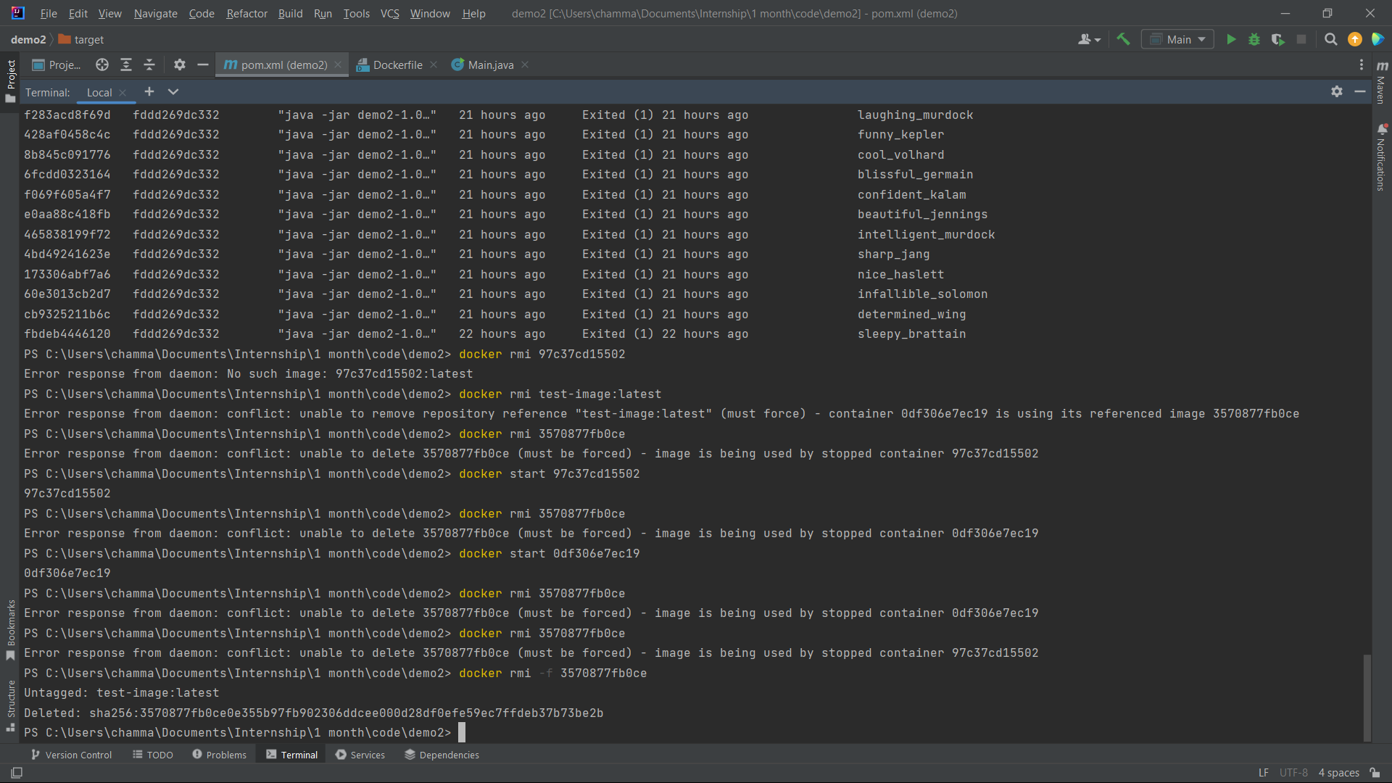

1. List all the docker images and show output

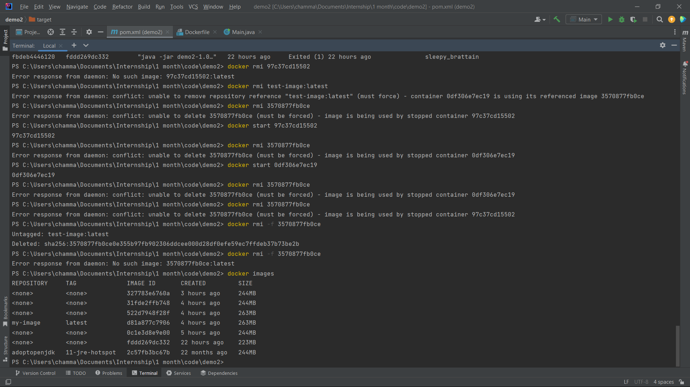

1. What is docker hub?

Docker Hub is a cloud-based registry service provided by Docker that allows developers to store, share, and manage Docker container images. It serves as a central repository for Docker images, making it easy to share your own images with others and use images created by the community.

1. Pull hello-world image from docker hub
2. Run hello-world image and show output

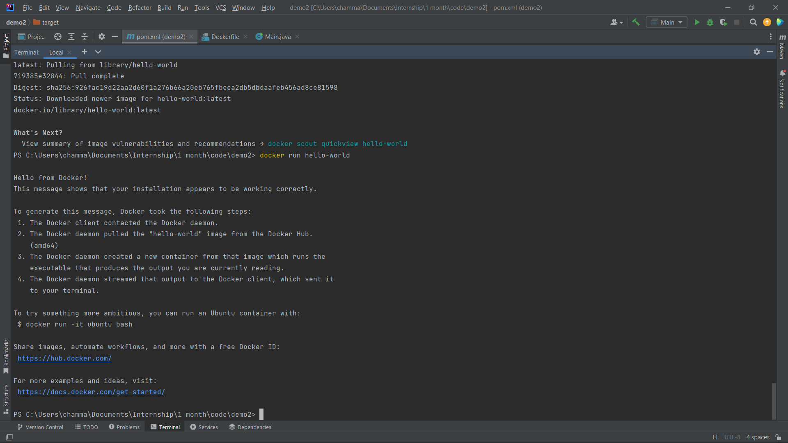

1. Pull and run mongodb as docker container
2. Open mongo shell

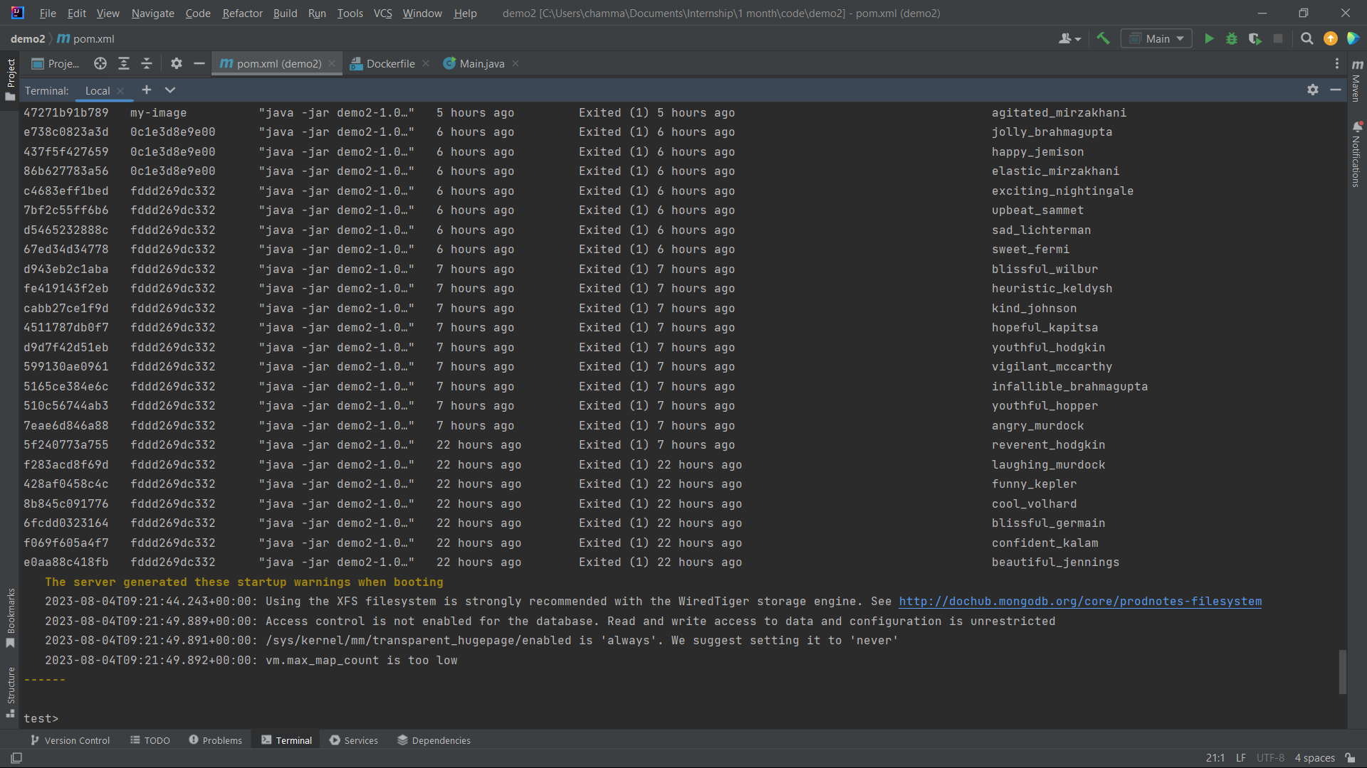

1. List mongodb databases

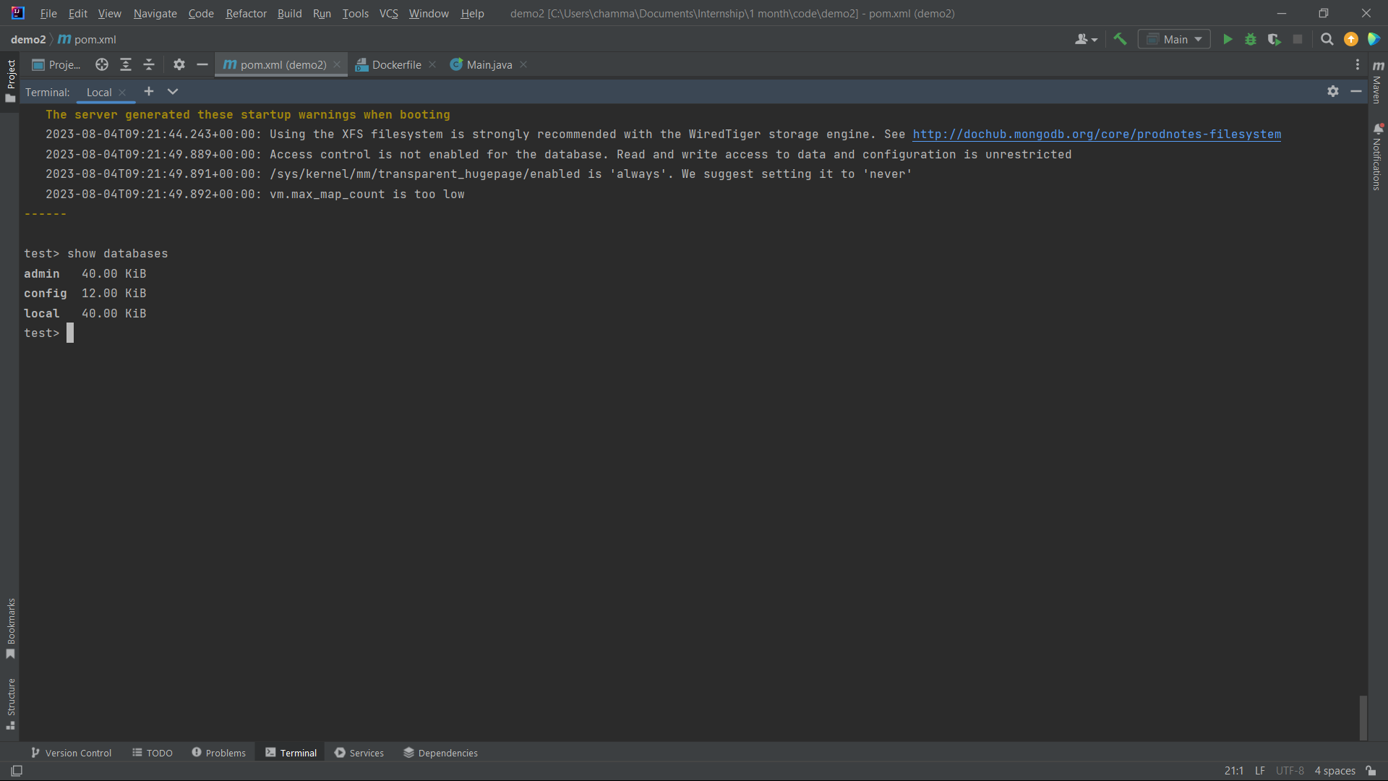

1. Add your codes and answer sheet to a directory named “docker-basic-training” and push it to your training github repository

